Cooking website

***INTRODUCTION :***

**Cooking** or **cookery** is the [art](https://en.wikipedia.org/wiki/Art), [technology](https://en.wikipedia.org/wiki/Technology), [science](https://en.wikipedia.org/wiki/Science) and [craft](https://en.wikipedia.org/wiki/Craft) of preparing [food](https://en.wikipedia.org/wiki/Food) for consumption. For someone cooking is passion.

***OBJECTIVES:***

* In this website we are providing you the healthy and tasty recipes for cooking lovers.
* Ingredients present in the recipes is easily available in the market at reasonable price.
* In this we will put a menu which help you to cook one type of food in different different ways.
* Recipes available in this will enhance the flavour and look of your food.
* The viewers can try different different recipies.
* As we know cooking preserve food for a longer time.
* Menu includes dishes that have different textures as soft ,crisp,hard,smooth,etc.

***MODULES:***

* Home
* Recent Recipes
* Recipe Details
* Chefs
* Blog
* Contacts

***MODULES DESCRIPTION:***

* Home:

->List of food items:You can search which type of food you want to

eat at your own choice.

->Recipe detail keyword:Here you can search recipe detail in step wise

Manner.

->search button

* Recent recipes:
* Breakfast-Mix prantha,aloo prantha,onion prantha,veg.macroni.
* Lunch-Rajmah,kadi paneer,mutter paneer,veg.biryani,boondi raita.
* Dinner-Mix veg kofta,Manchurian,seasonal vegetable,chilli paneer,chhole bhature,masala dosa.
* Deserts-Gulab jamun,black forest,besan sweets.

* Recipe-details:

1. **cooking macaroni:**

1. In a pan, heat 3 cups water and ½ teaspoon salt. Bring it to a boil.

2. Add 1 heaped cup macaroni or elbow macaroni (125 grams elbow macaroni).

3. Stir with a fork.

4. Begin to cook macaroni on medium to medium-high flame.

5. Cook macaroni till they are al dente – meaning they should have a slight bite to them.

6. Drain all the water and keep cooked macaroni aside.

7. Now add 1.25 to 1.5 cups of mix vegetables. Also add ¼ cup green peas. You can add vegetables like carrots, green beans, cauliflower, capsicum, baby corn, broccoli, potatoes etc. Add veggies of your choice. I added baby corn, carrots, green beans, potatoes, capsicum and green peas.

8.mix very well.

9.On a medium-low to medium flame simmer till the vegetables are cooked.

10. Once the vegetables are cooked and tender, add the cooked macaroni. some gravy or

Curry or sauce will be there in the pasta.

11.on a low to medium-low flame simmer for a few more minutes till the water is

absorbed.stir for few minutes.

12.serve macroni pasta hot or warm.

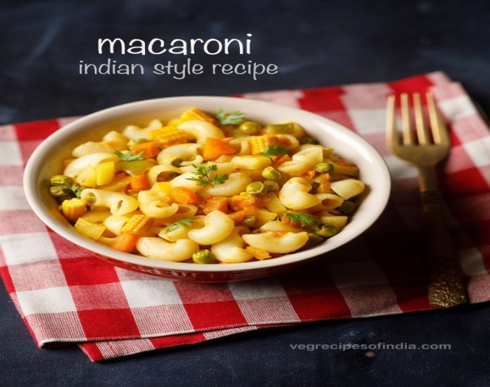

1. **Veg Biryani:**

1. Heat oil and add cumin seeds.

2. add the onions, garlic-ginger paste. Saute till brown.

3. Add vegetables, stir fry over low heat till half done.

4. Add coriander powder, garam masala, haldi, salt, chilli powder and green chillies.

5. Cook, covered for about 5 minutes and mix in the lemon juice and half the coriander.

6. The water should be absorbed by now. Remove half the vegetables and layer with half the rice.

7. Cover with the rest of the vegetable mixture and the rice again.

8. Leave over low heat, covered for 10 minutes or so and serve garnished with the coriander.

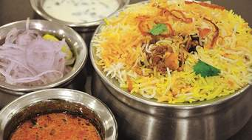

1. **Gulab Jamun:**

1.With the heel of your palm or the base of a flat metal bowl, mash the khoya, so that no grains remain.

2.Mix in the flour and baking soda and knead into firm dough. You can use a food processor too.

3.The dough should be firm but pliable and should not feel dry. If it does feel dry, wet your hands and work the dough again.

4.Shape the dough into marble-sized balls (jamuns) that are smooth and creaseless. The shape can be round or oblong.

5.Heat ghee in the kadahi till a piece of dough tossed in comes up at once.

6.Lower heat and fry a cube of bread till light brown (this lowers the temperature of the ghee).

7.Lift out bread and add as many jamuns as will fit in, without one touching the other.

8.Keeping the heat low, fry these till a golden brown all over.

9.Drain the jamuns out of the ghee, and fry the next lot, increasing the heat for a few seconds and then lowering it again before adding the jamuns.

10.Keep the gulab jamuns aside till the syrup is ready.

11.Mix the sugar and water and place over low heat, stirring till the sugar dissolves. Make sure it does not boil.

12.Increase the heat once the sugar dissolves, and then bring mixture to a boil.

13.Add the milk and water mixture and continue boiling over high flame, without stirring.

14.Skim off any scum that collects on the sides of the pan.

15.Cook till syrup thickens a bit. A finger dipped in slightly cold syrup should form a coating on it for a few seconds.

16.Take syrup off stove and cool for a minimum of half an hour. Strain through a fine nylon sieve or muslin cloth.

17.Add cardamom and bring syrup to a boil again.

18.Add the fried gulab jamuns to it and put off the heat. Let jamuns soak for at least half an hour before serving.

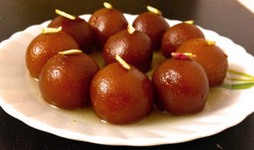

You can search which type of recipe details you want go to home module.

Here you will find recent recipe detail keyword.

* Chefs:

->Top 5 INDIAN Chef:

* 1. Sanjeev Kapoor
* 2. Vikas Khanna
* 3. Floyd Cardoz
* 4. Vineet Bhatia
* 5. Atul Kochhar

->We are providing the link where you can search the food recipe i.e.made by

these intelligent chef.

* **Blog:**

**->**our blog focuses on Indian Vegetarian Cooking and Baking with over 700 recipes.

**Highlights of the Blog:**

* All the recipes listed in our cooking website are tried and tested by our chef.
* They are not just quick, healthy but also made very simple with easy step by step cooking instructions.
* There are lots of ideas and recipes in the blog for nutritious meals for home cooking.
* Cooking website has a lot of easy to cook recipes and one pot meals without compromising on the taste or nutrition, especially for busy professionals and bachelors.
* **Contacts:**

->Feedback:If you tried our recipes then give feedback i.e.how useful

our recipes and how much you are satisfied with it.

->Suggestion:If you want to give any suggestion what we have to

make changes in our recipes in future.you are heartly

welcome.we will respect your suggestion and take it

positive.

**->**We will provide our contact number in home module.

***STRENGTH:***

* Content available via video on demand.

***OPPORTUNITY:***

* There are a lot of food lovers in INDIA. The website can use this fact to draw audience through delicious and attractive recipes.
* Can use cooking competitions on social media websites to publicize the channel.
* Can tie up with big hotels and restaurants through its recipes and chefs to spread word of mouth publicity.

NAME-> REGISTRATION NO-> ROLL-NO->

Name-> Registration no-> Roll-no->

Bhimavarapu Pavan Reddy 11902825 RK19TSB68

Nisha Kumari 11901660 RK19TSB69

Akanksha Maurya 11905066 RK19TSB70

Battu Siddhu Naik 11910376 RK19TSB71

Bhimavarapu Pavan Reddy 11902825 RK19TSB68

Nisha Kumari 11901660 RK19TSB69

Akanksha Maurya 11905066 RK19TSB70

Battu Siddhu Naik 11910376 RK19TSB71

->Module home and recent recipe will explain by Akanksha maurya.

->Module recipe details and chef will explain by Nisha kumari.

->Module blog will explain by Bhimavarapu pavan reddy.

->Module contacts will explain by Battu siddhu naik.